Phase - 2.5 Week – 3 Assignment
Assignment – 1
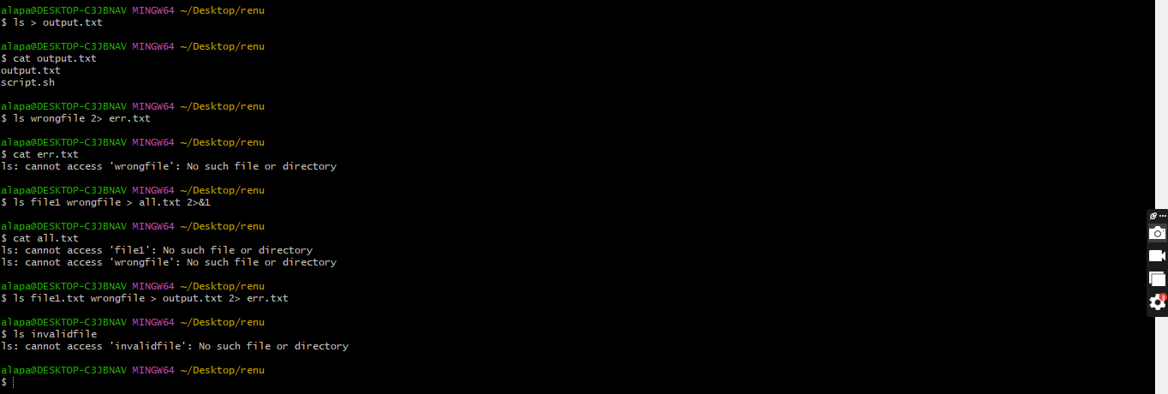
Assignment – 2
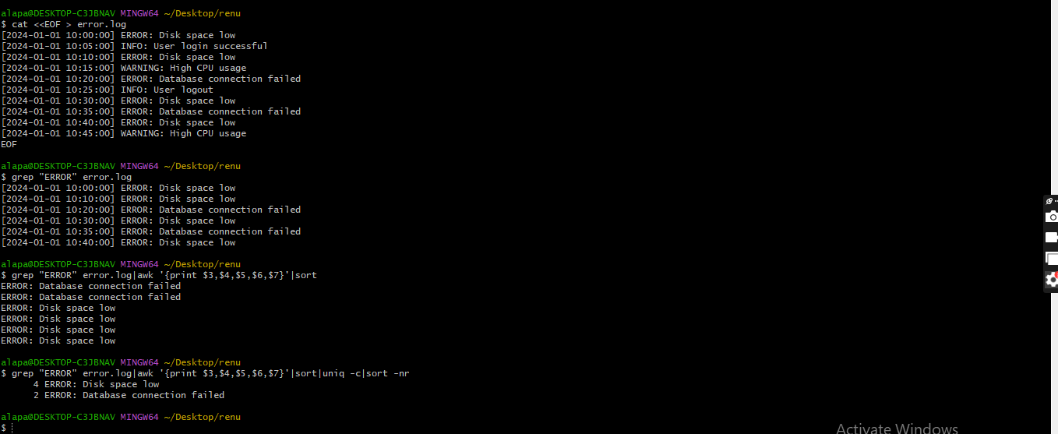
Assignment – 3
